**Chart It**

**Project Description**:

*Chart It* is a php application that allows one to draw an overlay on top of a jpeg image. It has been designed to assist users in libraries locate a particular resource in a building by call number. Once linked within an OPAC, patrons are able to access Chart It, identify the call number range where the resource they’re after is and see an image of the building and floor, with the particular stack highlighted.

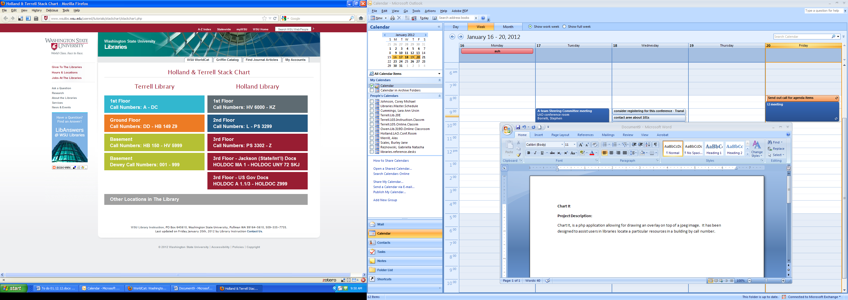**Why Chart It?**

Libraries in general, but particularly academic libraries house large collections in large buildings. Locating resources in these facilities can be frustrating and intimidating. Chart It assists patrons locate the resources they’re after, more easily by showing an image of the particular “stack” a resource is located by call number (see the example below). The resource locating and retrieval process is made more efficient through reducing the time required locating resources, and by reducing library anxiety as an additional finding aid.

**Example:**

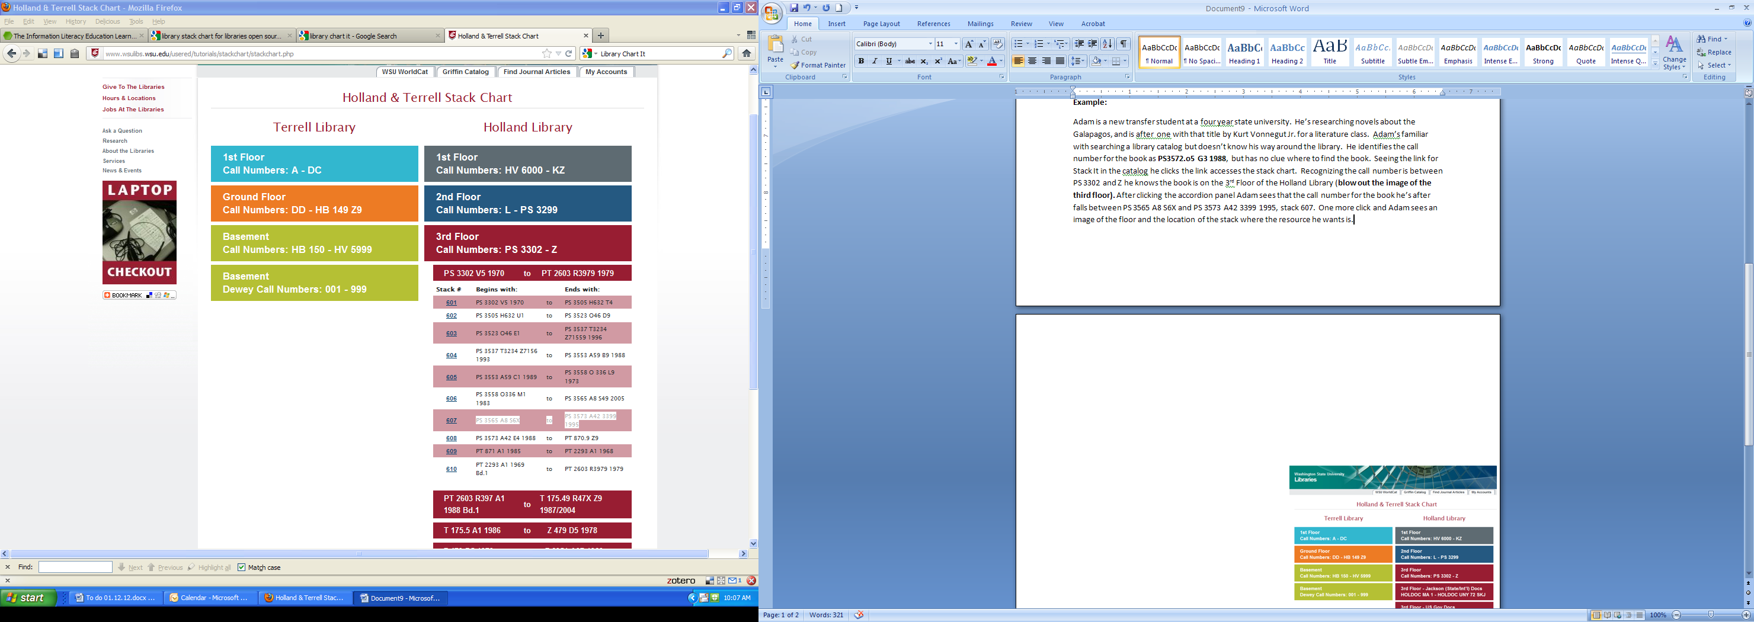Adam is a new transfer student at a four year state university. He’s researching novels about the Galapagos, and is after one with that title by Kurt Vonnegut Jr. for a literature class. He’s familiar with searching a library catalog but doesn’t know his way around the library. He identifies the call number for the book as **PS3572.O5 G3 1988**, but has no clue where to find the book. Seeing the link for Chart It in the catalog he clicks the link accesses the stack chart (see figure 1).

Recognizing the call number is between PS 3302 and Z he knows the book is on the 3rd Floor of the Holland Library**.** After clicking the accordion panel Adam sees that the call number for the book he’s after falls between **PS 3565 A8 S6X and PS 3573 A42 3399 1995**, *stack 607*. One more click and Adam sees an image of the floor and the location of the stack where the novel *Galapagos* is. Adam’s now knows not only that the library has a copy of the resource he wants, but is empowered to get it on his own without the additional hassle and embarrassment of having to ask for help.

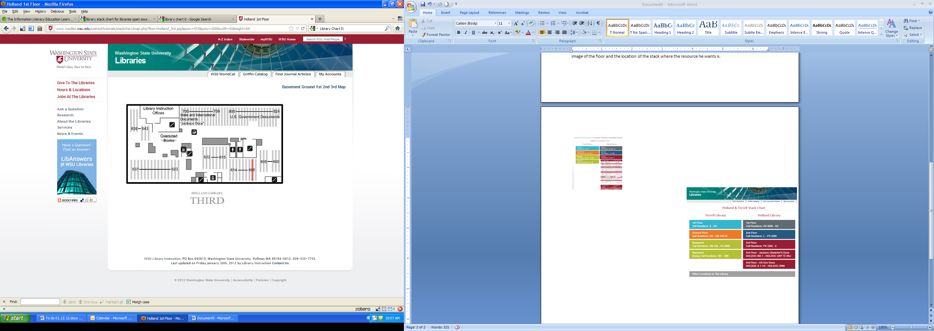

Installation

The default project configuration is intended to work right away. Copying the entire folder to PHP-enabled webserver should be enough.

The system has an embedded SQLite 2 database, as well as several supporting open source libraries like jQuery and Blueprint CSS.

User Operation

There are two main parts regarding user operation in Chart It: the first is locating a “stack” in the accordion-based user interface, and the second is checking its actual location in the floor map.

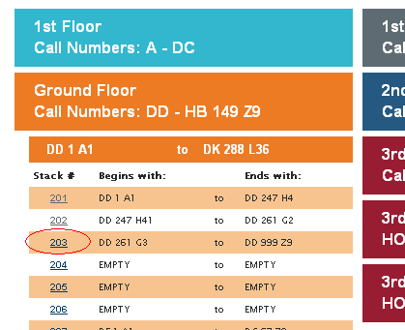The project is initially configured with the floors and stacks data from WSU Holland & Terrell Libraries. The initial screen displays the two libraries and its floors as header sections in the accordion control; when one is selected, it is expanded and groups of stacks are selectable as second level headers. The default group size of 10 is modifiable (see Admin Operation).

Each stack has configured a set of “coordinates” consisting of a floor image and the location of the stack on the image. The coordinates are displayed in a link with the stack number

Admin Operation

The application has an administrator section where stacks can be added, edited and removed from the database.

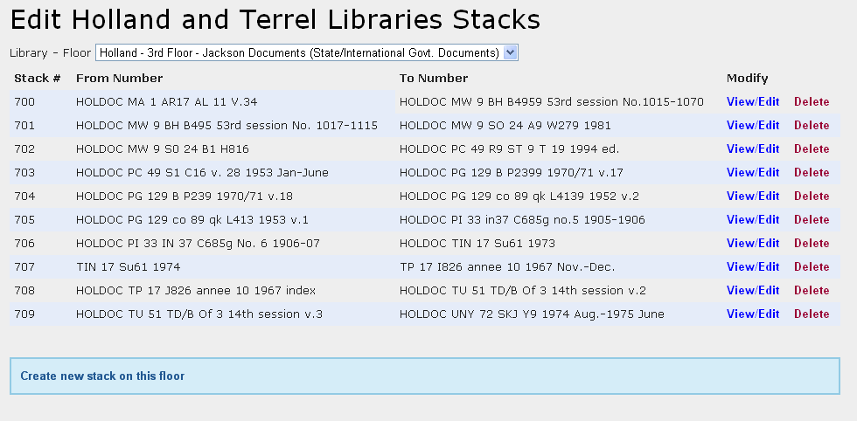

The initial selection combo displays the list of floors in the database. After picking one, the list of stacks is show, as well as links to edit and delete them, and to create new stacks.

The stack details screen allows setting values for stack name and call numbers, as well as selecting a map image and specifying a square overlay to indicate the exact location of the stack in the floor. The procedure is:

1. Select an image from the thumbnail list. The select image will be displayed below the form.
2. Draw a rectangle on the image with the mouse. The Map Coords field will reflect the coordinates with four numbers separated by hashes:
   1. X: horizontal position of the upper-left corner
   2. Y: vertical position of the upper-left corner
   3. W: rectangle width
   4. H: rectangle height

All numbers are in pixels.

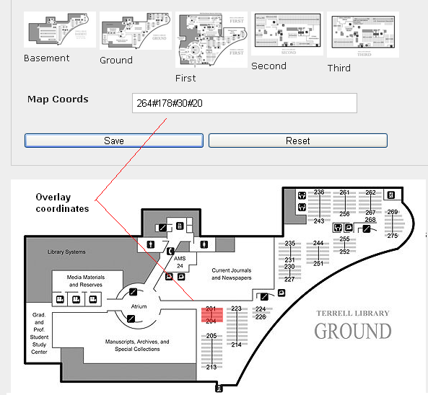

1. Alternatively, the Map Coords can be edited manually, and map will be redrawn automatically.

**Table of Contents:**

[I. Introduction](http://ile.codeplex.com/wikipage?title=introduction&referringTitle=Documentation)

[1. Application Description](http://ile.codeplex.com/wikipage?title=Introduction&referringTitle=Documentation&ANCHOR#appdescription)

[2. Theory behind the method](http://ile.codeplex.com/wikipage?title=Introduction&referringTitle=Documentation&ANCHOR#theory)

[II. Roles within the ILE application](http://ile.codeplex.com/wikipage?title=roles&referringTitle=Documentation)  
[III. Component Description](http://ile.codeplex.com/wikipage?title=components&referringTitle=Documentation)  
[IV. Installation](http://ile.codeplex.com/wikipage?title=installation&referringTitle=Documentation)  
[V. Maintenance](http://ile.codeplex.com/wikipage?title=maintenance&referringTitle=Documentation)  
[VI. Operating within the Environment](http://ile.codeplex.com/wikipage?title=operating&referringTitle=Documentation)